**Design decisions:**

1.I have defined the region according to this application requirements at the backend side so it will only allow the data pertaining to the coordinates within Germany to be sent to the device.

2.I have catch the errors gracefully for the app experience to be robust.

3.I have tested the components with the jest framework as well as the webservice api.

**Instructions to be followed for the medwingfrontend app:**

1.Install node package manager: npm install

2.Install react navigation: npm i –S react-navigation

3.Install react native maps: npm i –S react-native-maps

4.Go to the ios project and install pods: pod install

5.Install jest framework for testing: npm i -D jest

6.Install isomorphic fetch for api testing:

npm install --save isomorphic-fetch es6-promise

7.Go to the ios project in the app and open the project workspace file in xcode and run the project.

**Instructions to be followed for the medwingbackend app:**

1. Install node package manager: npm install
2. Run the following command to start the dev360 server: turbo devserver

**Instructions for the app:**

1. The app loads the pins from mlab database
2. You can add further pins onto the map by long press on the map
3. You can touch the markers on the map and drag to alter their location
4. You can tap on the markers to select them
5. You can delete the marker by tapping the delete button
6. You can edit the marker by pressing the edit button and then entering the description to alter the description of the marker

(Note: If you get build failed error which looks something like this: “…/ios/build/ModuleCache.noindex/1939WCWRX3UP5' 1 error generated.

** BUILD FAILED ** …”

then do following steps as the solution:

1. Select the app build like this

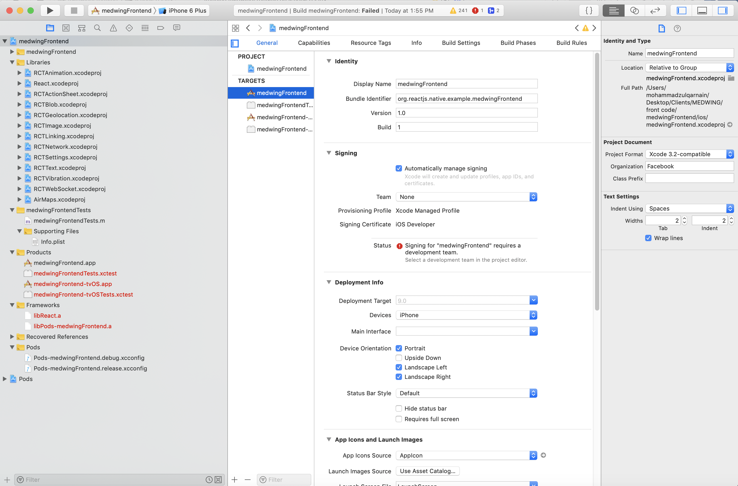

1. Scroll down to the bottom section that is linked library section and remove the libAirMaps.a file.
2. Run the project in xcode.

